BenefitsIQ Analytics Tools Guide
AWS Portal, S3, SQS, EMR Serverless, Kafka UI, and Airflow, Gitlab
Prepared for BenefitsIQ Analytics / Recon Operations

1. Access Overview
Tool / Service | Purpose | Access Notes
AWS Portal / ADFS/Gitlab | Sign in to AWS console using ADFS role-based access. | Use AIEE ADFS portal and select the approved AWS role.
Amazon SQS | Holds file-arrival messages for SmartDev/data load processing. | Used by Airflow watcher DAG to trigger downstream processing.
Amazon S3 | Stores artifacts, logs, Iceberg warehouse data, and SmartDev landed/decrypted files. | Two main buckets are used: analytics-recon and be-iq-npd-app.
EMR Serverless | Runs PySpark jobs for Recon and SmartDev processing. | Airflow submits jobs to EMR Serverless.
Kafka UI | Provides visibility into Kafka/MSK topics and published messages. | Used to validate CDC and SmartDev message publishing.
Airflow | Orchestrates DAGs and triggers EMR Serverless jobs. | Deployed on OCP and used for both Recon and SmartDev pipelines.
JDBC / Iceberg Catalog | Stores Iceberg table catalog metadata in PostgreSQL (RDS) while table data and metadata files remain in S3. | Configured through Helm/ConfigMap and AWS Secrets Manager; Spark initializes JdbcCatalog during EMR Serverless jobs.

2. AWS Portal Access
Use ADFS login to access the AWS console and select the appropriate BenefitsIQ role.
Item | Value
ADFS Portal | https://sts.aiee-cfg.com/adfs/ls/idpinitiatedsignon
Username Format | <username>@aiee-cfg.com
Password | <Use enterprise credential / do not document password>
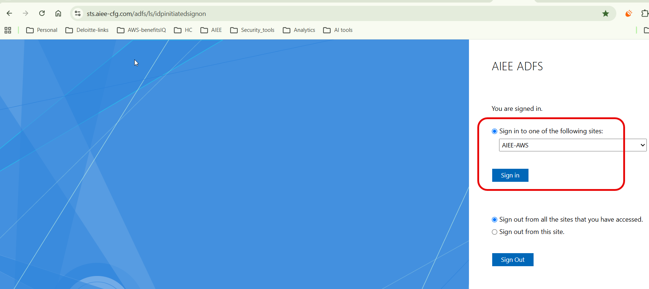
ADFS sign-in page and role selection workflow.
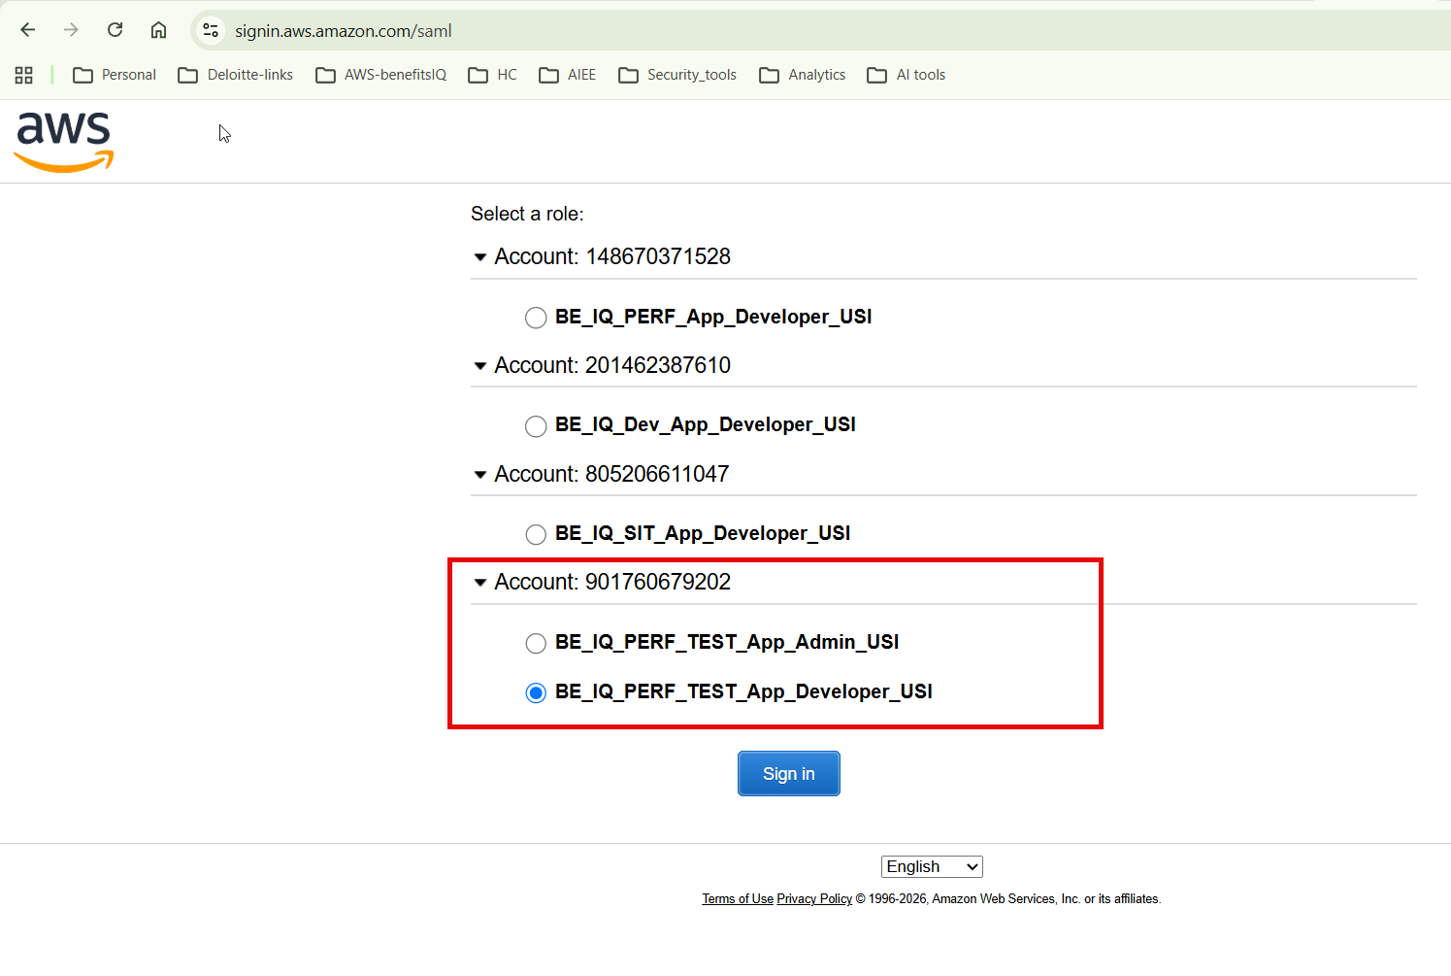
AWS role selection screen for BenefitsIQ account access.

3. Amazon SQS
Amazon SQS is used as the message buffer for S3 object-created notifications. When a SmartDev file lands in the configured S3 prefix, S3 sends an event notification to SQS. Airflow reads the SQS message and triggers the downstream EMR Serverless PySpark processing DAG.
Queue / Topic | Usage
be-iq-data-load | Receives SmartDev S3 object-created messages and triggers the Airflow watcher flow.
biq-recon-smartdev-dlq | Used for dead-letter / failed message handling if configured.
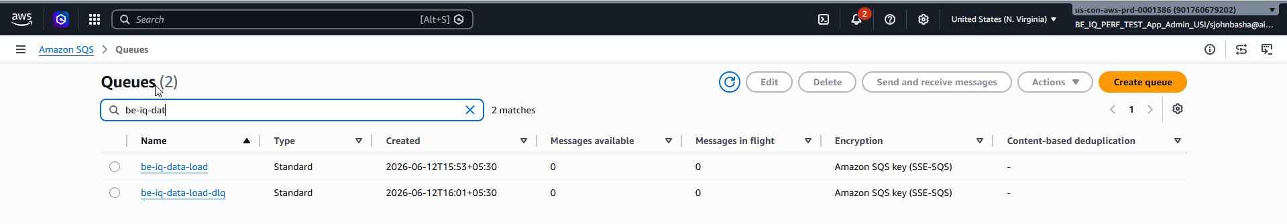
SQS queues used for SmartDev/Data Load eventing.

4. Amazon S3 Buckets and Paths
Bucket / Path | Purpose
s3://be-iq-npd-analytics-recon/emr-serverless-logs/ | EMR Serverless driver/executor logs.
s3://be-iq-npd-analytics-recon/iceberg/ | Iceberg warehouse for Recon data and metadata.
s3://be-iq-npd-analytics-recon/smartdev/jobs/dev/ | SmartDev PySpark entrypoint scripts.
s3://be-iq-npd-analytics-recon/smartdev/packages/dev/ | SmartDev PySpark package zip files and dependencies.
s3://be-iq-npd-analytics-recon/smartdev/config/dev/ | SmartDev source schema and configuration files.
s3://be-iq-npd-app/smartdev/dev/data-load/bronze/landing/ | SmartDev SFTP-to-S3 landing path for encrypted files.
s3://be-iq-npd-app/smartdev/dev/data-load/silver/decrypted/ | SmartDev decrypted output path after processing.
s3://be-iq-npd-analytics-recon/manifests/smartdev/ | SmartDev manifest/idempotency tracking location.
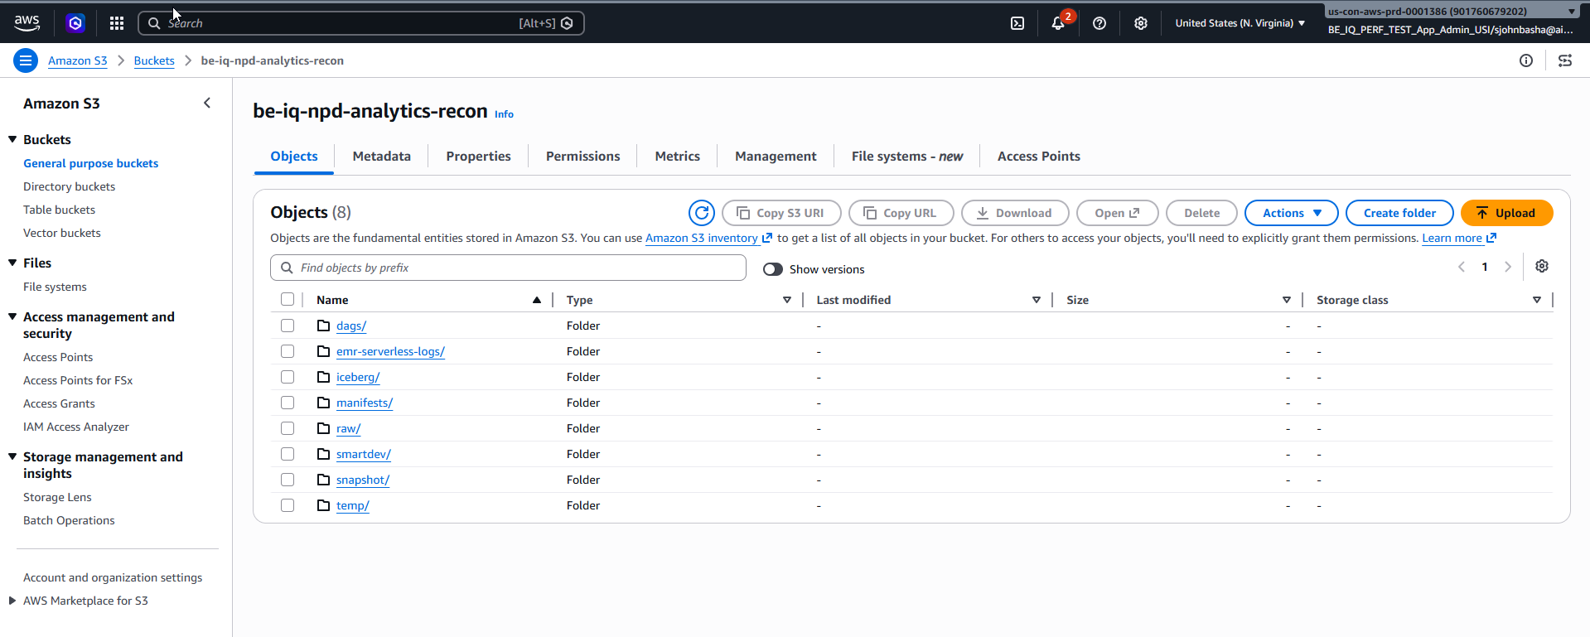
S3 bucket structure used by BenefitsIQ Analytics.
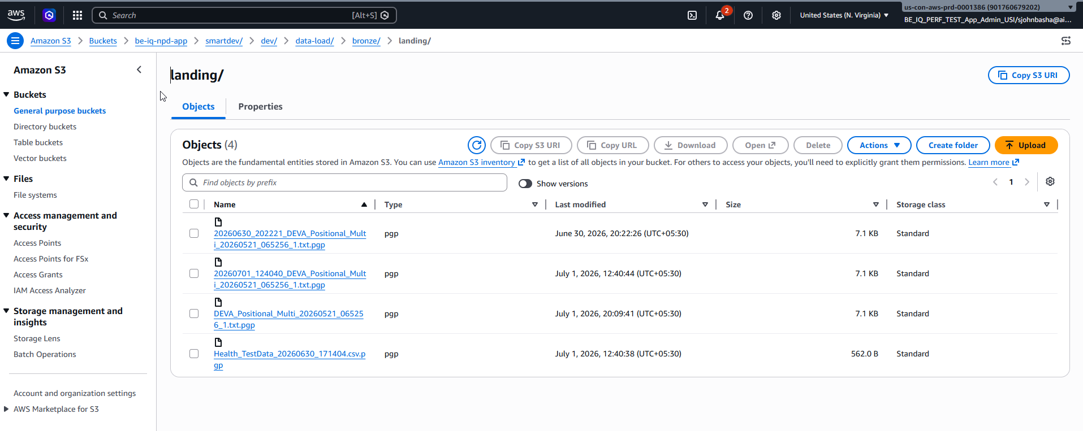
SmartDev landing path in S3 where inbound PGP files arrive.

5. AWS EMR Serverless
EMR Serverless is the managed Spark runtime used by Recon and SmartDev PySpark jobs. Airflow submits the job to EMR Serverless, and EMR provisions the Spark driver and executors automatically for the job run.
Item | Value
Application Name | be-iq-analytics-recon-emr
Application ID | 00g4uq4im6993v09
Release | EMR 7.12.0
Runtime Type | Spark
Primary Use | Run Recon and SmartDev PySpark jobs.
EMR Serverless Link | https://es-8sxl9mc73s58ll6mrbwfit4xp.emrstudio-prod.us-east-1.amazonaws.com/#/serverless-applications/00g4uq4im6993v09
Operational Check: In EMR Serverless, validate job run status, runtime duration, driver/executor logs, and resource allocation before closing a pipeline run.
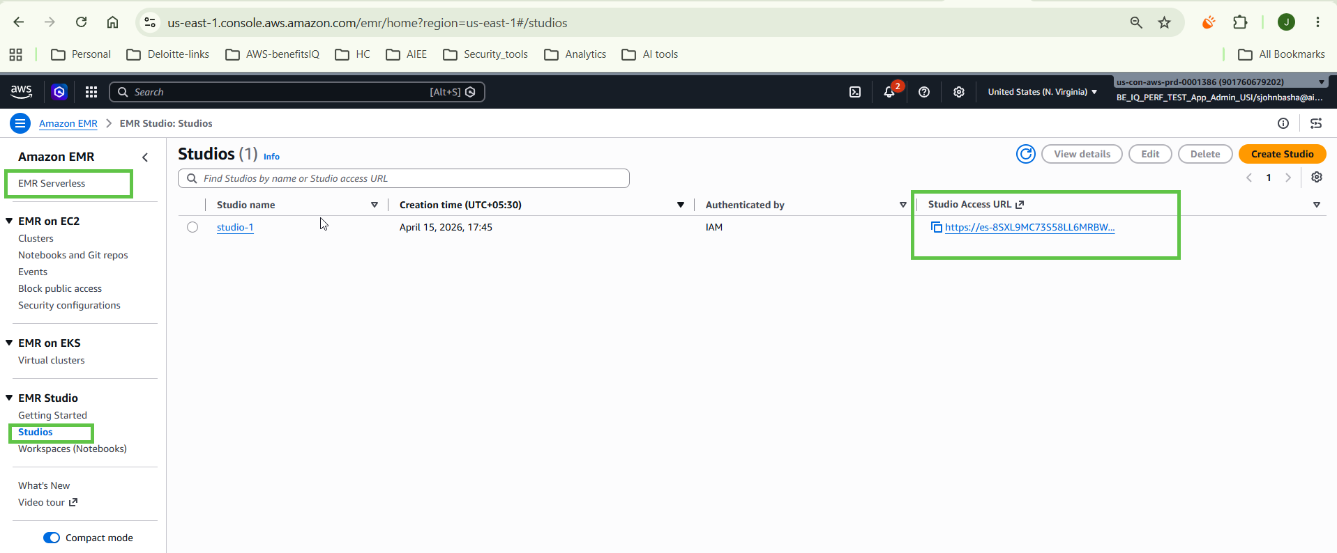
EMR Studio and EMR Serverless application navigation.
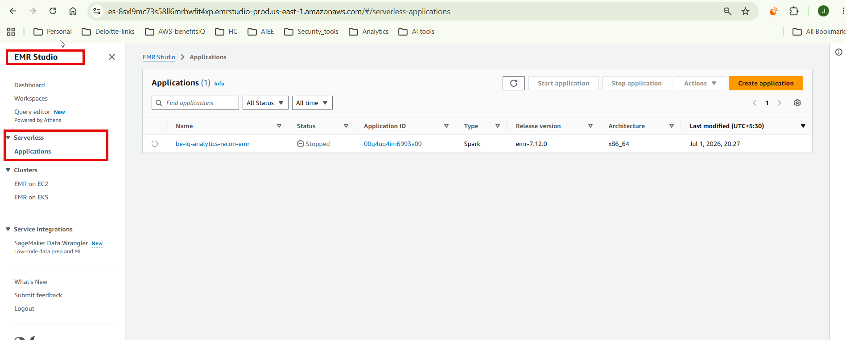
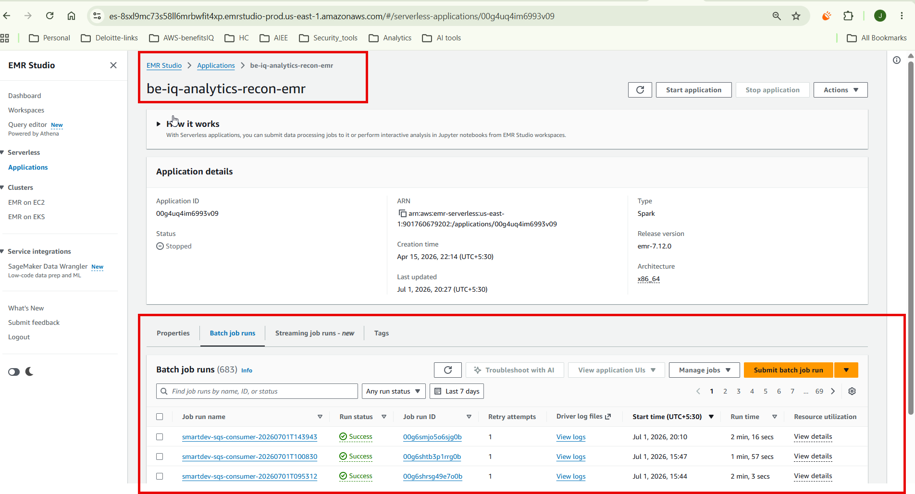
EMR Serverless application details and job run history.

6. Kafka UI
Kafka UI provides operational visibility into the MSK/Kafka topics. It is used to verify CDC topics, SmartDev raw topic messages, partitions, offsets, and message counts.
Item | Value
Kafka UI URL | https://biq-analytics-recon-kafka-ui-route-biq-analytics-recon-dev.apps.ocp.npd-biq.idap-oc-usaws.com
SmartDev Topic | biq-recon.smartdev.raw
Usage | Inspect topics, offsets, consumers, and message payloads.

Kafka UI cluster overview and topic list.
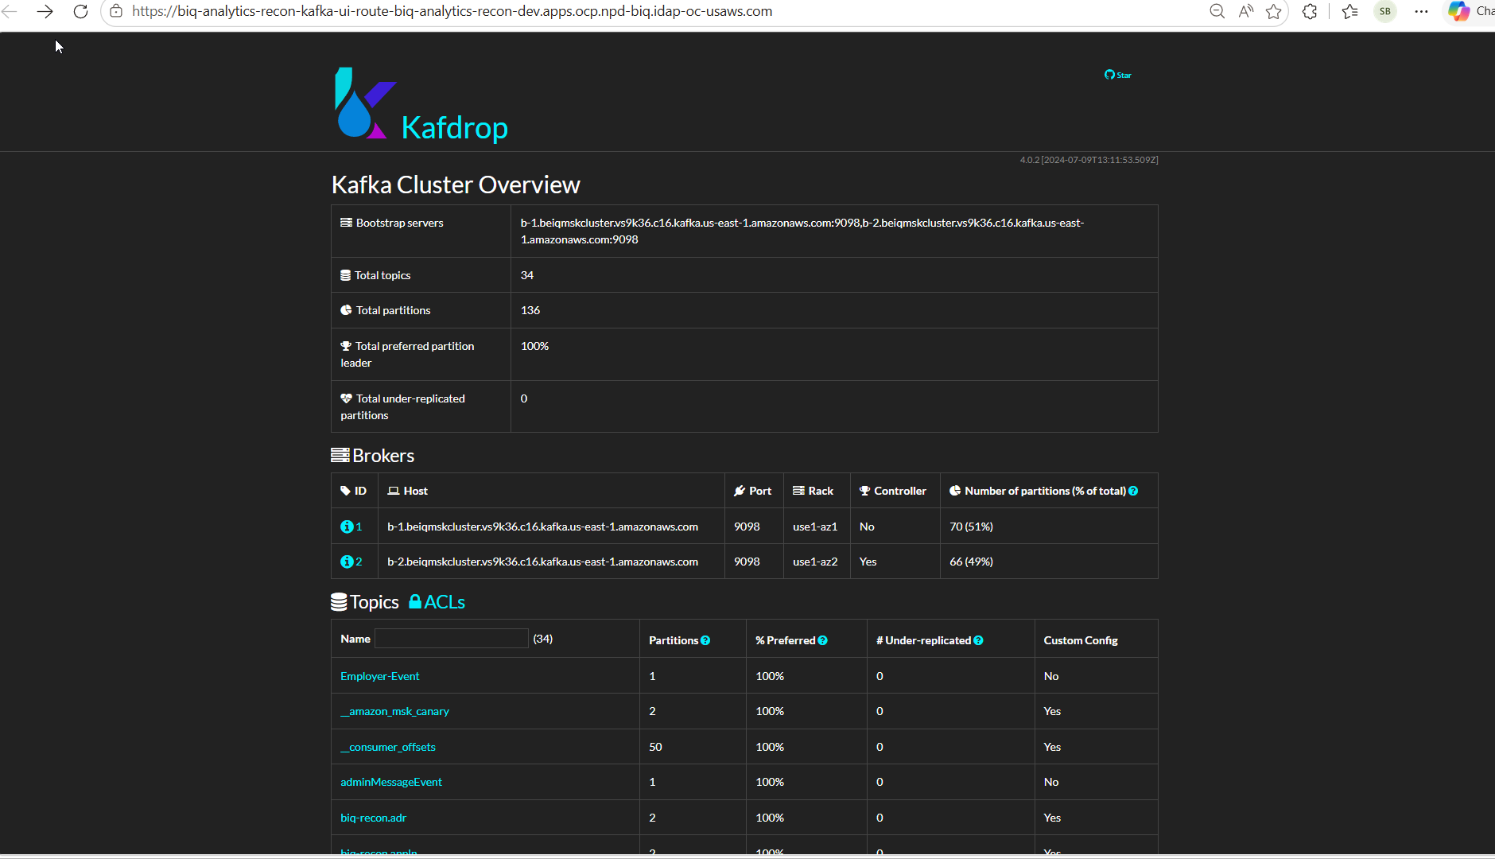
Kafka topic detail view for SmartDev raw messages.

7. Airflow
Airflow orchestrates the Recon and SmartDev pipelines. The SmartDev event-driven flow uses a watcher DAG to read SQS messages and trigger the downstream PySpark ingestion DAG. The downstream DAG submits the Spark job to EMR Serverless.
Item | Value
Airflow URL | https://biq-analytics-recon-airflow-dev.apps.ocp.npd-biq.idap-oc-usaws.com
Username | airflow
Password | <Managed through approved secret process; do not document plain text password>
Key DAGs | biq_recon_pipeline, smartdev_sqs_asset_watcher, smartdev_pyspark_ingestion_runner
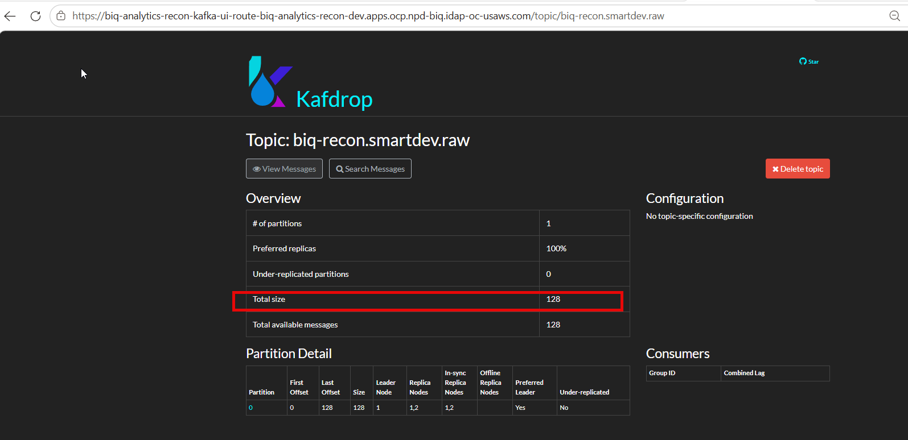
Airflow DAG list showing Recon and SmartDev DAGs.

8. SmartDev Event-Driven Processing Flow
Step | Description
1. File Landing | SmartDev uploads a PGP-encrypted file through SFTP. The file lands in the S3 landing prefix.
2. S3 Event | S3 ObjectCreated event is generated for the landing prefix.
3. SQS Message | The event notification is sent to the SQS queue.
4. Airflow Watcher | The watcher DAG reads the SQS message and extracts bucket, key, and filename.
5. PySpark Runner | The downstream DAG submits the EMR Serverless PySpark job.
6. Processing | PySpark decrypts the PGP file, validates schema, performs idempotency checks, and publishes records to Kafka.
End-to-End Flow: SFTP -> S3 Landing -> S3 Event Notification -> Amazon SQS -> Airflow Watcher DAG -> EMR Serverless PySpark Job -> PGP Decryption -> Schema Validation -> Kafka Publishing.

9. Gitlab portal
Use ADFS login to access the Gitlab console and select the appropriate BenefitsIQ role.
Item | Value
ADFS Portal | https://sts.aiee-cfg.com/adfs/ls/idpinitiatedsignon
Username Format | <username>@aiee-cfg.com
Password | <Use enterprise credential / do not document password>
Gitlab portal link | https://gitlab.aiee-cfg.com/aicloud-benefitsiq/benefitsiq-app
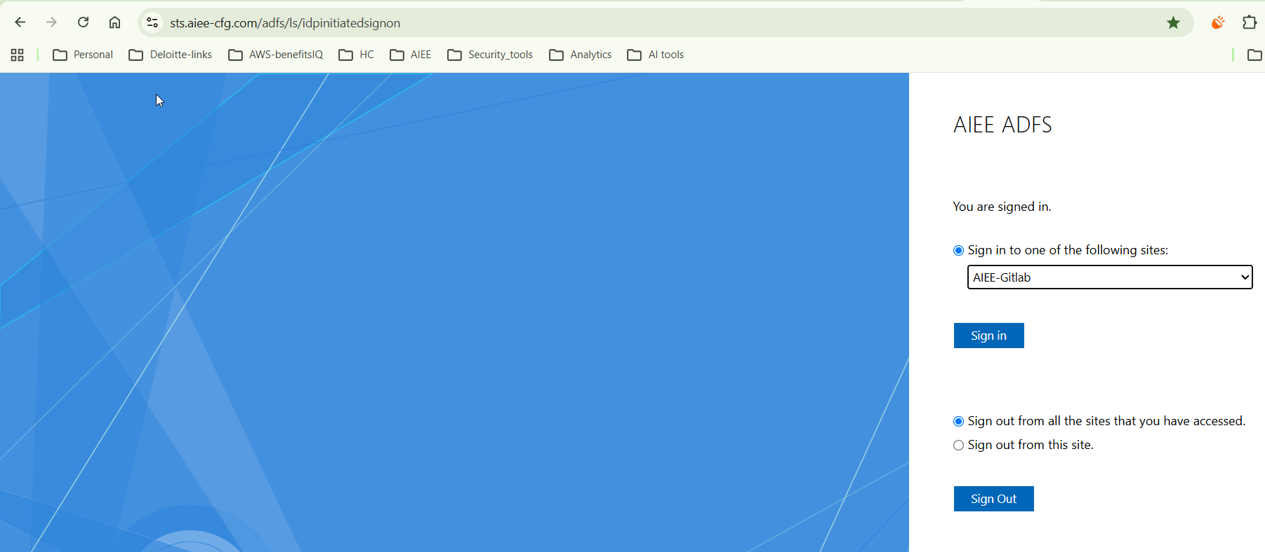
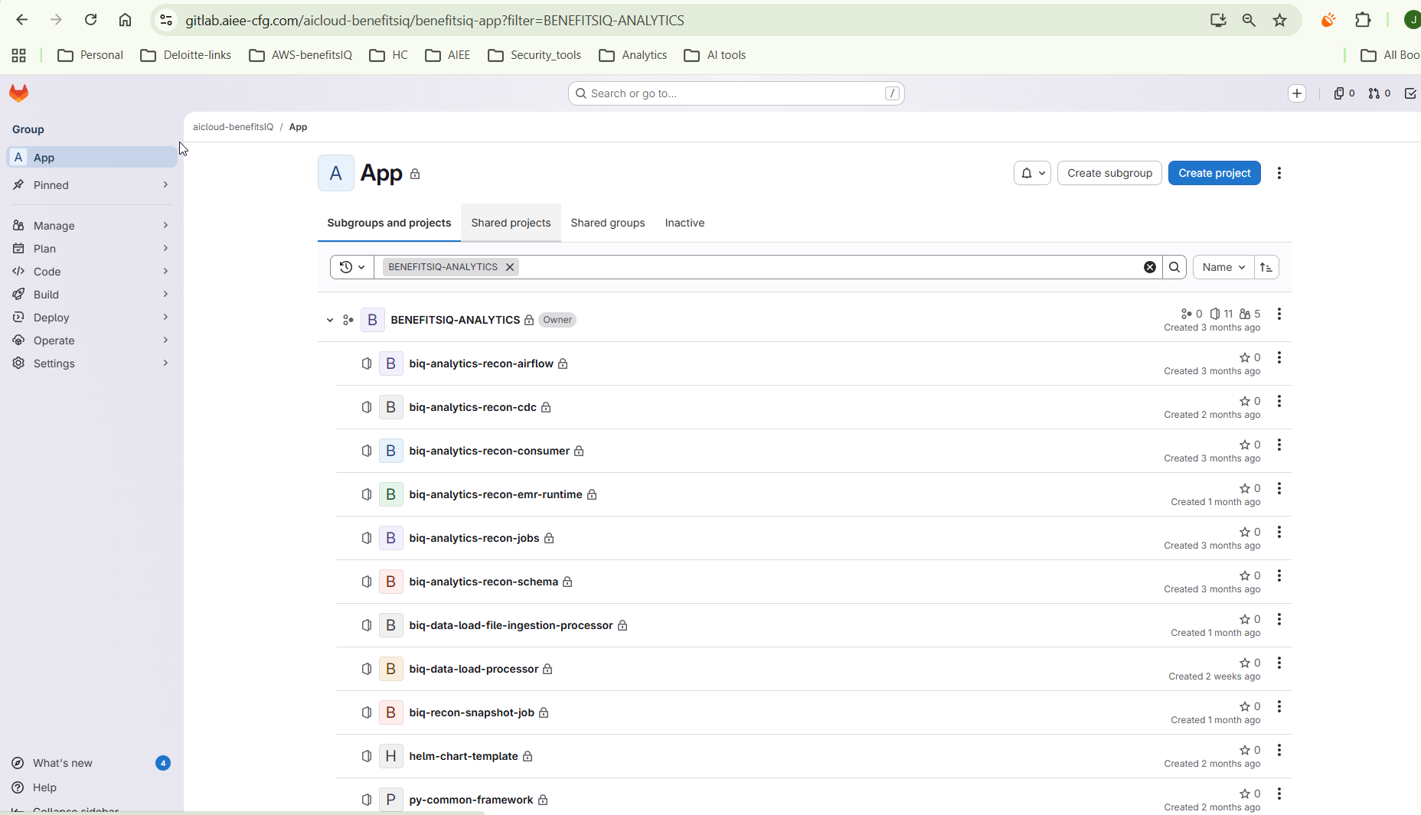
Local Gitlab Setup:
Create a personal access token:
- In the upper-right corner, select your avatar.
- Select Edit profile.
- In the left sidebar, select Access > Personal access tokens.
- From the Generate token dropdown list, select Legacy token.
- In Token name, enter a name for the token.
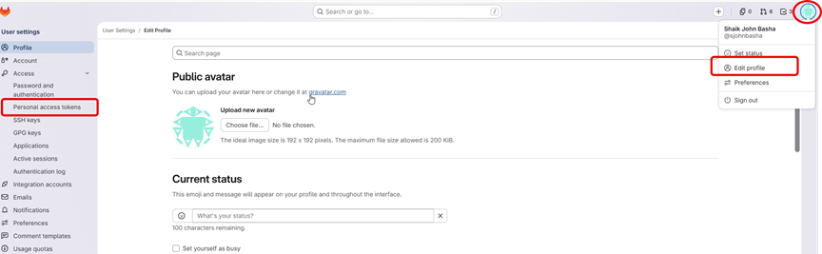
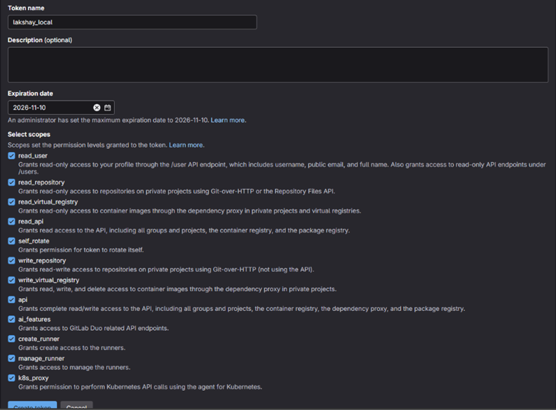
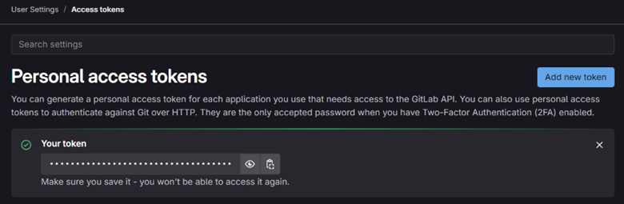
git config --global user.name “sjohnbasha” à Update your Gitlab username
git config --global user.email sjohnbasha@aiee-cfg.com à update your Email

git config --global core.longpaths true
git config --system core.longpaths true

git clone https://gitlab.aiee-cfg.com/aicloud-benefitsiq/benefitsiq-app/benefitsiq-analytics/biq-analytics-recon-cdc.git
git remote set-url origin https://gitlab.aiee-cfg.com/aicloud-benefitsiq/benefitsiq-app/benefitsiq-analytics/biq-analytics-recon-cdc.git
git checkout -b feature/BI-21677-data-load => {Create new feature branch}
(or )
git checkout feature/BI-21677-data-load => {Create branch in the GitLab portal & switch feature branch}
git add.
git commit -m "Updated the connectivity"
git push origin feature/BI-21677-data-load

Enter the AIEE username and password
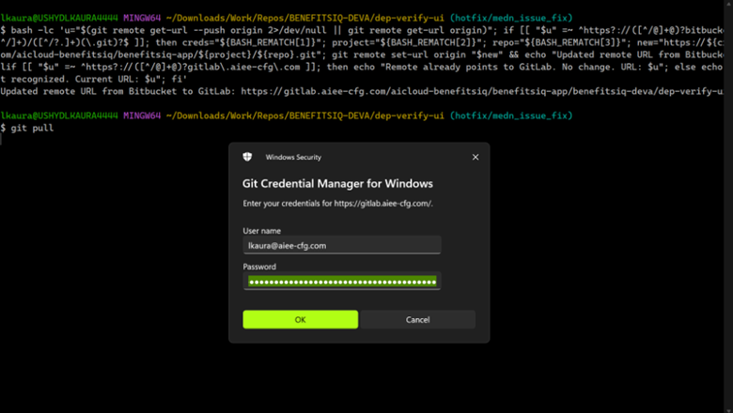
Now git clone must be successful-
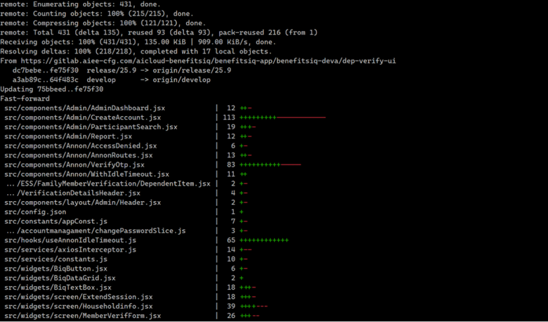

10. Sonar portal
Item | Value
Sonar Portal | https://biq-perf-test-sonarqube.idap-oc-usaws.com/
Username | sonar-dev
Password | Healthchoice@123

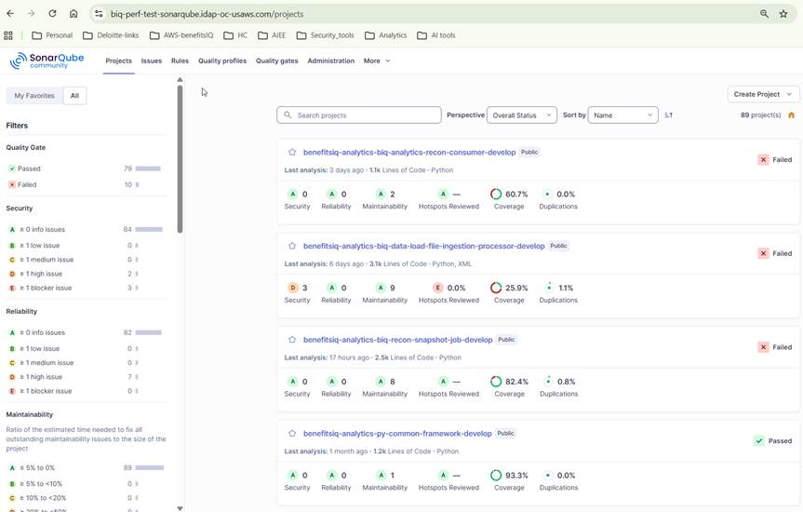

11. JDBC and Iceberg Catalog
This section documents the JDBC-backed Apache Iceberg catalog setup used by BenefitsIQ Analytics. Iceberg uses a JdbcCatalog backed by PostgreSQL (RDS), while S3 remains the warehouse for table data and metadata files.
Component | Purpose | BenefitsIQ Usage
PostgreSQL / RDS | JDBC catalog backend for Iceberg table metadata. | Stores catalog metadata tables used by Spark JdbcCatalog.
Amazon S3 warehouse | Physical storage for Iceberg data files and metadata JSON/manifest files. | Warehouse path: s3://be-iq-npd-analytics-recon/iceberg/
AWS Secrets Manager | Secure storage for JDBC username/password and connection details. | Secrets are mounted/synced to Airflow using ExternalSecret.
Helm / ConfigMap | Application configuration management. | Provides Iceberg catalog URI, warehouse path, catalog name, and Spark config.
Airflow | Pipeline orchestration. | Submits Spark jobs to EMR Serverless with the catalog configuration.
EMR Serverless / Spark | Compute runtime. | Initializes org.apache.iceberg.spark.SparkCatalog with type=jdbc.

11.1 End-to-End Connectivity
Step | Flow | Description
1 | AWS Secrets Manager -> ExternalSecret -> Airflow | JDBC credentials are sourced from AWS Secrets Manager and made available to Airflow without documenting plain text passwords.
2 | Helm / ConfigMap -> Airflow | Iceberg catalog configuration, JDBC URI, and warehouse location are deployed with Helm-managed configuration.
3 | Airflow -> EMR Serverless | Airflow submits the Spark job and passes catalog-related Spark configuration to EMR Serverless.
4 | Spark -> JdbcCatalog -> PostgreSQL | Spark initializes Iceberg JdbcCatalog and reads/writes catalog metadata through JDBC.
5 | Iceberg -> S3 warehouse | Iceberg table data, metadata files, manifests, and snapshots are stored in S3.

End-to-End Flow: Secrets Manager -> ExternalSecret -> Airflow -> EMR Serverless -> Spark JdbcCatalog -> PostgreSQL catalog metadata + S3 Iceberg warehouse.

11.2 JDBC Usage
Usage Area | Description | Operational Notes
Airflow metadata database | Airflow uses a database for scheduler, DAG run, task instance, and operational state metadata. | Do not store credentials in the guide. Use approved secret retrieval and rotation process.
Iceberg catalog backend | Iceberg JdbcCatalog uses PostgreSQL to track namespaces and table references. | Validate catalog tables exist and Spark can create/list namespaces and tables.
Audit/control tables | Operational PostgreSQL access may be used for audit, reconciliation, and control tables. | Restrict access by role and avoid direct manual updates unless approved.

11.3 Spark JDBC Catalog Configuration
Spark configuration example
spark.sql.catalog.biq_catalog=org.apache.iceberg.spark.SparkCatalog
spark.sql.catalog.biq_catalog.type=jdbc
spark.sql.catalog.biq_catalog.uri=jdbc:postgresql://<rds-endpoint>:5432/<database>
spark.sql.catalog.biq_catalog.jdbc.user=<from-secret>
spark.sql.catalog.biq_catalog.jdbc.password=<from-secret>
spark.sql.catalog.biq_catalog.warehouse=s3://be-iq-npd-analytics-recon/iceberg/
spark.sql.catalog.biq_catalog.io-impl=org.apache.iceberg.aws.s3.S3FileIO
spark.sql.extensions=org.apache.iceberg.spark.extensions.IcebergSparkSessionExtensions

PySpark initialization example
from pyspark.sql import SparkSession

spark = (
SparkSession.builder
.appName("benefitsiq-iceberg-jdbc-catalog")
.config("spark.sql.catalog.biq_catalog", "org.apache.iceberg.spark.SparkCatalog")
.config("spark.sql.catalog.biq_catalog.type", "jdbc")
.config("spark.sql.catalog.biq_catalog.uri", "jdbc:postgresql://<rds-endpoint>:5432/<database>")
.config("spark.sql.catalog.biq_catalog.jdbc.user", "<from-secret>")
.config("spark.sql.catalog.biq_catalog.jdbc.password", "<from-secret>")
.config("spark.sql.catalog.biq_catalog.warehouse", "s3://be-iq-npd-analytics-recon/iceberg/")
.config("spark.sql.catalog.biq_catalog.io-impl", "org.apache.iceberg.aws.s3.S3FileIO")
.config("spark.sql.extensions", "org.apache.iceberg.spark.extensions.IcebergSparkSessionExtensions")
.getOrCreate()
)

spark.sql("SHOW NAMESPACES IN biq_catalog").show(truncate=False)

11.4 Helm / ConfigMap and Secret Pattern
ConfigMap pattern
ICEBERG_CATALOG_NAME=biq_catalog
ICEBERG_CATALOG_TYPE=jdbc
ICEBERG_WAREHOUSE=s3://be-iq-npd-analytics-recon/iceberg/
ICEBERG_JDBC_URI=jdbc:postgresql://<rds-endpoint>:5432/<database>

ExternalSecret / environment pattern
ICEBERG_JDBC_USER=<resolved-from-aws-secrets-manager>
ICEBERG_JDBC_PASSWORD=<resolved-from-aws-secrets-manager>
# Do not store plain text passwords in GitLab, Helm values, Airflow variables, or this document.

11. How to submit the Data load Job on EMR serverless GUIDE (SMARTDEV) - 10 STEPS
A) Required permissions and setup
1) AWS IAM permissions for local caller:
- secretsmanager:GetSecretValue (secret: benefitsiq-analytics/biq-analytics-recon-airflow)
- emr-serverless:StartJobRun, emr-serverless:GetJobRun, emr-serverless:GetApplication
- s3:PutObject, s3:GetObject, s3:ListBucket on be-iq-npd-app and be-iq-npd-analytics-recon
- sqs:SendMessage on https://sqs.us-east-1.amazonaws.com/901760679202/be-iq-data-load
2) EMR execution role permissions:
- S3 read/write for artifacts and logs
- MSK publish access with AWS_MSK_IAM
3) Required resources:
- EMR App: 00g4uq4im6993v09
- EMR Role: arn:aws:iam::901760679202:role/emr-serverless-execution-role
- Topic: biq-recon.smartdev.raw
B) 10-step local to EMR process
Step 1: Install the python in local use the python 11 or above
Step 2: Verify test file path exists.
Step 3: Verify the script e2e_test_queue_plaintext_kafka_publish.py
Gitlab portal link : https://gitlab.aiee-cfg.com/aicloud-benefitsiq/benefitsiq-app/benefitsiq-analytics/biq-data-load-file-ingestion-processor/-/tree/feature/jb-local-setup?ref_type=heads
Step 5: Run command:
python C:\Temp\e2e_test_queue_plaintext_kafka_publish.py --mode direct-publish --asset-root smartdev --sample-file "<FULL_PATH_TO_TEST_FILE>"
Step 6: Confirm upload log to s3://be-iq-npd-app/smartdev/dev/data-load/bronze/landing/...
Step 7: Capture EMR jobRunId from submission log.
Step 8: Wait for state transition PENDING -> SCHEDULED -> RUNNING -> SUCCESS.
Step 9: Validate stdout signals: status=SUCCESS, consumer_status=COMPLETE, processed_sqs_messages>0, processed_s3_objects>0, message_count>0.
Step 10: Validate output in Kafka topic biq-recon.smartdev.raw.

